Yawei laser thick outbreak, performance continued to multiply
2017-12-16 Yawei laser equipment division
Yawei laser equipment department concerned click me yo
Regularly push Yawei laser hot information, new technology and new technology, use and maintenance of quality content! It's right to pay attention to us.
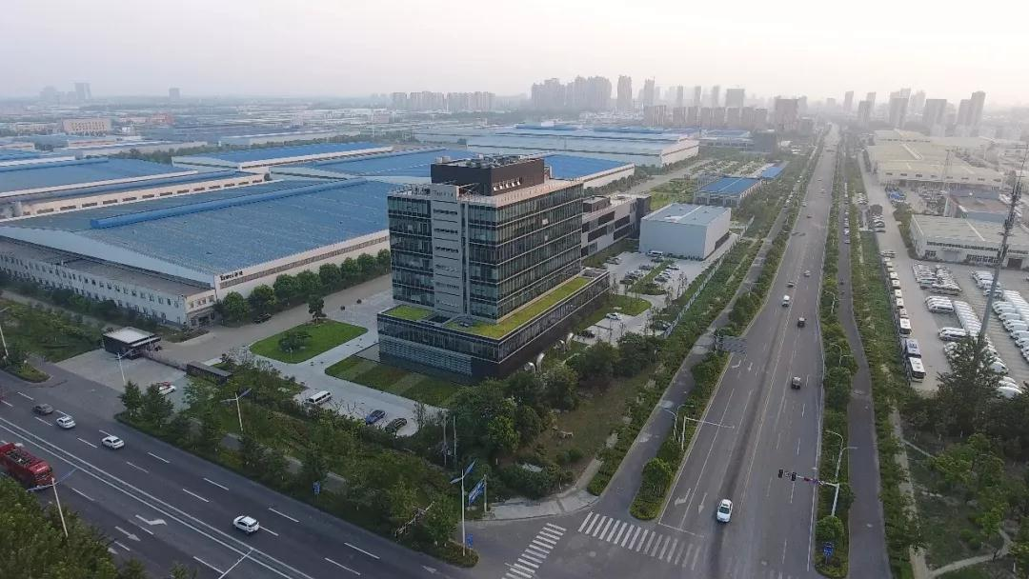
Jiangsu Yawei machine tool Limited by Share Ltd (hereinafter referred to as Yawei shares, stock code: 002559) is a well-known high-end equipment and intelligent manufacturing solutions provider, founded in 1956, is located in Jiangsu city of Yangzhou province in 2011, Shenzhen SME board listed, automotive, transportation, aviation, machinery, electrical appliances, metal and other major industry well-known enterprises provide metal forming machine tools, laser processing equipment, industrial robots, automated production line, factory management software and multi industry oriented intelligent / smart factory workshop solutions.

Laser processing equipment is Yawei the current rapid development of key business segments. Laser processing with high precision, high efficiency and high flexibility characteristics, effectively reduce the difficulty of manufacturing enterprises and small batch, multi batch, complex product processing cycle, in the industry to achieve a wide range of applications, and continuously expand new areas of application, instead of traditional technology and equipment. Decades of accumulated technology based on shares Yawei laser equipment business, is also closely follow the trend of the rapid growth of the industry has made a breakthrough, in 2017 the annual effective contract will exceed 600 million yuan, for 2 consecutive years, an increase of more than 100%, has become one of the core pillars of business company.
The laser business includes Yawei high power fiber laser cutting of 3D laser welding machine, and additive manufacturing systems (including 3D printing), laser processing automation production line. Yawei laser business products with high quality and high efficiency cutting advantage at home and abroad in many markets, widely used in professional sheet metal processing, electric power, elevator, rail transportation, automobile manufacturing, engineering machinery, agricultural machinery, energy industry, aerospace and other fields.
At present, Yawei has an annual output of 1000 sets of more high-quality laser processing equipment and automation system of production capacity, can effectively support the laser future business continued to grow rapidly.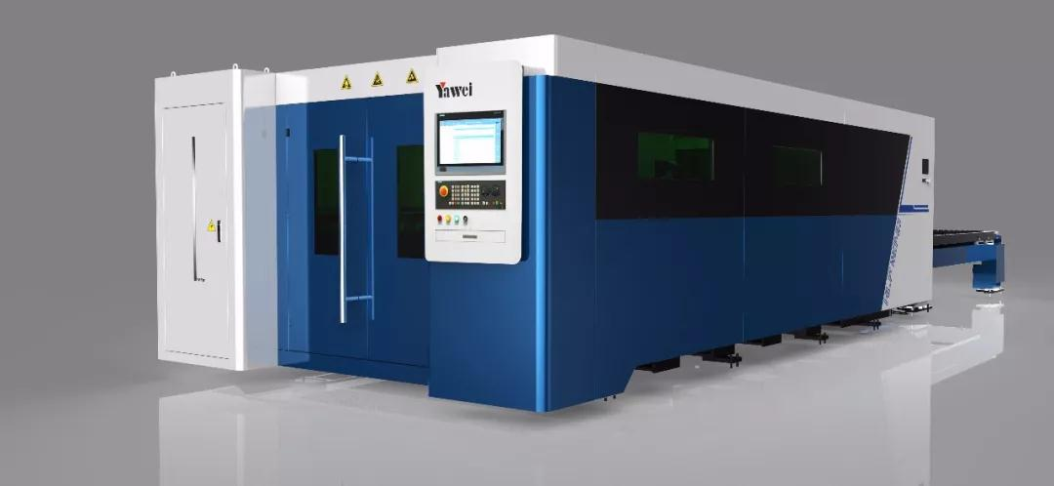
The development of laser Yawei business
At the beginning of 2008, we began to develop the laser cutting machine independently. In 2010, the first CO2 laser cutting machine was put on the market and gained praise from customers and industries. At that time, it became one of the few enterprises that could batch laser cutting machine in China.
By the end of 2013, Yawei shares of Italy and the famous puma Po (Prima-Power) laser equipment company, introduced the technology and application of laser technology, thus greatly reducing the laser and the advanced international counterparts Yawei business gap, not only in terms of design and application technology of reborn, and the concept of European advanced manufacturing and mature quality control the new method is more cognitive, from Yawei laser development onto the fast lane, Yawei fiber laser cutting machine technology and manufacturing level is becoming mature.
September 2014, Yawei wholly acquired robot laser cutting in the industry leading Wuxi chuangkeyuan laser equipment Limited by Share Ltd, to further consolidate the industry advantages in laser cutting. Ltd is mainly in the field of automobile manufacturing to provide robot laser processing equipment system integration and related technical services for customers.
In March 2015, after the development and application of technical personnel to the transfer of technology digestion and absorption and re innovation, focus on Yawei patents, grafting the decades of manufacturing experience, precision machine technical parameters and the cutting performance of leading a new generation of HLF series high power fiber laser light cutting machine domestic market. Because of its rich functions, advanced technology, stable quality and reliable cutting precision, the industry's highest standards, competitive advantages, quickly occupied the commanding heights of industry, not only has the traditional advantages in Yawei sheet metal industry won many customers, but also won the high evaluation on the quality and efficiency of demanding steel processing industry of laser cutting orders come continually, the market share has been rising.
September 2016, Yawei shares with Zhegong Da laser Advanced Manufacturing Research Institute jointly founded the Zhejiang University of Technology, Yawei shares joint research center ", both sides to build Jiangsu Provincial Key Laboratory for the project foundation, will focus on the laser welding, laser additive manufacturing and 3D printing research on the key technology of laser processing and market promotion.
In 2017, the laser industry needs rapid growth, product sales are way Yawei laser sales growth far exceeds the stride forward singing militant songs, the average level of the industry, the industry ranked first echelon.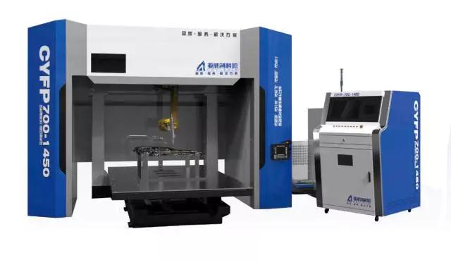
Yawei laser business development support ability
1. leading advantages of Technology: the introduction of innovation investment and international technical cooperation
Over the years, always adhere to the leading Yahweh as the representative of the core technology to the strategic concept. In recent years, bear more than 5 provincial key scientific and technological projects, 3 new products in Jiangsu province were identified as the first sets of major equipment, 36 new products have been identified as provincial high-tech products, won the provincial science and technology progress award 5, received 125 patents, including 15 invention patents, a software copyright right 4, chaired or participated in the drafting of national and industry standards 5. At the same time, Yawei also pays attention to the integration of global resources, has with the Swiss SMS company, Italy SLM company, Japan Nisshinbo company and other foreign technology companies, well-known enterprise technology and investment cooperation; maintain close long-term cooperative relations with Tsinghua University, Southeast University, Hohai University and other famous universities, continue to promote enterprise technological innovation, strengthen the promotion of Yawei technology advantage.

2. advantages of production and manufacturing: comprehensive information and lean production
In the product manufacturing process, Yawei has advanced processing testing and measurement, more than 300 sets of equipment, imported CNC boring and milling machine, vertical machining center and Longmen and other major CNC precision high efficiency and large processing center more than 100 sets, three coordinate measuring instrument, laser interferometer and other types of precision testing instruments more than 10 sets. Advanced processing equipment and precision testing instruments have played a powerful guarantee for improving the quality of the products and improving the production efficiency. Yahweh pays attention to promote the application of information technology in the production process. Through the SAP system of the whole product manufacturing process of capital flow, data flow and information flow to fully organize, transfer, purchase, storage, the production and marketing, and financial and other aspects of reasonable allocation and utilization, data integrity creates effective transfer, through technical data and production of all inventory management production inventory timely dynamic monitoring, the whole manufacturing process, so that the cost of each part, each work center cost, each order costs at a glance, the cost of production and operation to get effective control, greatly enhance the market strain capacity. At present, the key processing and testing equipment have been basically numerically controlled, and the numerical control rate of the key processes has reached 100%. The world's most advanced manufacturing technology and management methods, to enhance the physical quality of the endless, improve production efficiency and reduce manufacturing cost, shorten the delivery cycle, continue to promote the construction of agile production system, and gradually realize the manufacturing level and management level of the leading domestic production target.

3. advantage of customer service: perfect the sales network and the quality of service
The full coverage of the network, to serve the customers with zero distance, Yawei zero trouble idea to bring a full range of seamless technology and good customer service customer experience. At present, the company has 42 sales and service offices in China, and has a sales agency in more than 40 countries. The increasingly perfect domestic and international marketing service network provides customers with high-end CNC forming machine tools and complete sets of equipment, while providing a full range of technical after-sales service. Yawei machine tool equipment health care system is about to launch, is the function of the software RFID data acquisition technology and independent development based on the real-time data acquisition and remote monitoring of the running state of CNC machine tools and data, combined with the cloud platform and large data platform, data analysis ability, realize intelligent fault diagnosis. Compared with domestic and foreign counterparts, Yawei can provide the most timely and efficient customer service, the service quality of Yahweh has been widely recognized by customers.

The future, Yahweh will continue to deepen the development strategy of focused companies quality resources, connotation of "growth + extension type expansion wheel drive. Through the internal and external business development investment simultaneously in two ways, and constantly improve the laser industry chain layout, focus on the development of intelligent laser equipment as the representative of the high-end manufacturing and integrated laser solutions, and actively expand the field of consumer electronics industry, covering the field of automotive electronics, semiconductor, artificial intelligence and other precision laser machining, or provide material composite processing capacity, production line automation / factory intelligent integrated solutions for customers, adhere to innovation driven, green development, continuing to create value for customers, the practice of "2025 China manufacturing", to a target power manufacturing power for their contribution to the wisdom of China, intelligent manufacturing, factory more lofty goals ahead.

To be a first-class international laser equipment and solution service provider
Yawei manufacturing experience of more than 60 years of precipitation, lean production management modernization, strategic cooperation supplier of world-class, full life cycle service, as your solution menace from the rear.
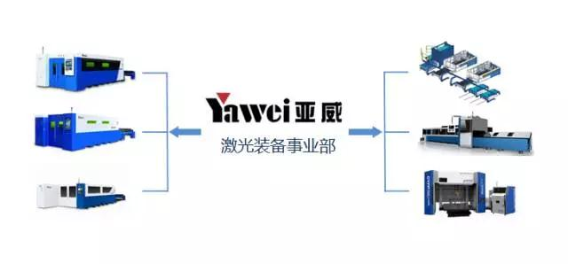


According to the two-dimensional code, please pay attention to Yawei laser equipment division

Service hotline: 400-000-2559

